

WECARE Massage & Natural Theraphy

**GROUP MEMBERS**

* **Dinithi Vithanage**
* **Shemal Ashen Jude Jayawardena Geekiyanage**
* **Yu Liu**
* **Xi ting jia**

Contents

1.0 Project description 3

2.0 Project scope of the full final-release 4

3.0 Project sponsor/client/customer signed 5

4.0 Project development and release ICT infrastructure 6

Reference MIT course and learning outcomes 7

## 1.0 Project description

**for non-ICT-technical stakeholders and general audience.** Write here: minimum **TWO** pages, maximum **TEN** pages.

* [___/10] Justification for the project: Why a new ICT solution is required. Include some market and ICT technology research, plus available ICT solutions.

Wecare massage established in 2015 is a small company with only 6 employees, the primary business goal or service offered is catering to clients that require relaxation services, currently the company has a simplistic informational website that has been created with an online web site development tool namely wix.com.

During further investigation of the website along with the set of client meetings conducted we discovered that the client required a more interactive site and as most of its clients are usually the working-class population of the inner Brisbane city location the site should be accessible on the go. This developed a need for the business to have a responsive website.

Taking it one step further, we as a team suggested in building a massage booking section on to the website as well. Thereby allowing clients to further reduce the time taken to make a call and book an appointment.

This would generate more customers as well as acquire a greater order in running the business. The client would know in advance about a scheduled future while also saving cost on labour for answering calls for booking.

**Market Research**

There exists high competition in the wellness therapy industry, and to be on top of the game is utterly important. To have an appealing, fully functional and user-friendly website is a plus point to any user which would result in better customer loyalty and also attract new ones. Wellness spas may have high levels of service extensively, but the attraction of a customer with convenience can be just as important as the core service.

In doing research in and around the area where We Care is located and in consultation with the client there were two main competitors that were identified. After conducting a research on each of their websites the following points were noted.

* **PhysioLogix Therapy Solutions** 
  + Website is not responsive however has a much easier navigation and clearer information structure than compared to WeCare.
* **Ebb & flow - Day Spa** 
  + The website is responsive and does include a very well designed online booking system which s gives them a competitive advantage of WeCare. However, they do not have a membership form which the proposed solution for this project will include to have an all-round website.

**ICT Technology Research**

* The versatility of the web page is essential as a customer would use a number of devices and even screen types to view. To have a responsive website that adapts to such screens and devices will make the service initiation even more pleasant. This will help reduce the time taken to convert an enquiry into a potential sale.
* The client issues membership cards for customers and those that are regular, reach a free service at a certain stage. But this card is not online for website users to use through. If an active membership card can help customers achieve discounts online, it would assist the success of this business greater than ever before.
* Research pages of specific types of discomforts with corresponding services that are designed for such matters, so that customers, even if confused about what they want, would have a clear vision about what they need. With regards to allergens, if any product does have effects, to have it mentioned so that readers would know what is being used and what is not.
* Displaying pictures and clips with a selection of soothing tunes in order to have a perfect understanding of the wellness spa and the type of professional services they offer, will aid the customer to view and choose, acting as an additional attraction of the website.
* ‘Bottom Up’ buttons on the page would come in handy since the viewer would not need to scroll all the way up back to the top, instead, with a click of a button, be directed back to the top of the page.
* A website background, which has a stronger appeal on whoever is viewing the website. Instead of having the existing background format, with a creative yet simple scene, the entirety of the website will be attractive to the user.

During the client meeting the following items were clearly discussed as a part of their requirements and in staying ahead of competition that the company was facing:

* Customers often requested if they could book online
* Customers are looking for easy on the go solution
* A lot of competition in this industry
* Website is not responsive so it is time consuming to book
* Current membership card is offline
* Add a contact us page for leaving a comment.
* Gallery for pictures of the shop
* Careers for information of hire

**Competitors? The Gap shopping centre has 3 the same type stores**

As the business is growing in size so are the requirements and the needs to be more competitive in the market and be up to date with the technological advancements that are taking place.

* [___/5] Project goals: Describe exactly what and how your proposed ICT solution will be delivered to the client.

1. Content rich interactive site
2. Responsive website
3. Massage booking facility
4. Links to social media
5. Overall easily navigational website
6. Membership Login Page
7. Security within the website- SSL Connection website (Future Development)
8. Careers page for hire information

* [___/5] Justify between two and four major milestones with timeline. Is your proposed schedule too ambitious (over-optimistic) or too conservative?

The major milestones of the project would be as follows, we have divided the milestone into four and thereafter subdivided sub milestones within each.

**Milestone 1**

Initial creation of the overall website pages with an overall responsive website.

* + Include proper navigation with bread crumbs
  + Simple user navigation options with hyperlinks to navigate

**Milestone 2**

Database connectivity with regard to all the pages that require sign up forms or information to be store

* Member Sign Up Page
* Careers page connectivity

**Milestone 3**

* Booking engine Connectivity

This will be the main part of the website that would be the key design feature.

**Milestone 4**

Overall website testing.

* Careers page connectivity

**[_____/20 marks, SLO-1, SLO-2, BLO-S3, MLO-S5]**

## 2.0 Project scope of the full final-release

**(Project audit at the end of CP3047/CP5047 subject). Clearly specify the scope of alpha-release (Project audit at the end of CP3046/CP5046 subject), and .** Write here: Minimum **TWO** pages, maximum **TEN** pages.

**Available days:** PASS-level (minimum) effort is 1-day and maximum is 3-days per teaching week (assume 12 weeks per study period), per team member. For example: 12 x 2 = 24 days is the minimum for a team with 2 students, 12x2x3=72

**, BLO-S5, MLO-K1, MLO-S5]**

**12 x 4 x 2= 38**

**48**

3.0 Project sponsor/client/customer signed**/agreed to the scopes of the alpha-release and the final-release.**

Cut/Paste clients’ email here, or show signed the preceding “**Project scope**” to your marking lecturer.

**[_____/20 marks, SLO-1, SLO-2, SLO-3, BLO-K1, BLO-S3, MLO-K1, MLO-S4, MLO-S5]**

4.0 Project development and release ICT infrastructure**.**

This must include development environment, programming languages, source code repositories (Configuration Management), project collaboration tools, and development tools. Write here: minimum **TWO** pages, maximum **TEN** pages.

* [___/5 marks] **Configuration Management**/version control, e.g. git, github, heroku, bitbucket;

GIT HUB

SLACK and WhatsApp

* [___/5 marks] **Project tools**. Programming languages/IDEs, e.g. php/WebStorm, java/IntelliJ; Building tools/procedures, e.g. git-push to heroku; e.g. how to set-up your development environment for a new team member
  + Dreamweaver for basic designing
  + PHP
  + SQL
  + HTML5
* [___/5 marks] **Testing** tools, data and procedures (what and how you are planning to test), e.g. junit; Client testing and access to release, e.g. domain name, domain hosting;

**Use Domain Name to open website**

**Domain Hosting to create database recording customers details**

Client training document, and procedures; Release testing tools, data and procedures (what and how you are planning to test);

* + Video for usage for website users list in treatment page
  + Training Documents for the client
* [___/5 marks] **Prototypes are demonstrated to justify the proposed alpha-release**;

**Can we make an ER DIAGRAM WITH SOME SAMPLE PAGES?**

**Home: pics, contact link, Login form, specials, Facebook. Links**

**Treatment: our treatment (professional + service + Steam Eye Mask) + Price List?**

**Specials - discounts**

**Online booking – linking website - https://app.shedul.com/online_bookings/59886/link**

**Membership (sign in-sign up-log off)**

**Careers - advantages**

**About us -- Insurance supports- our contact**

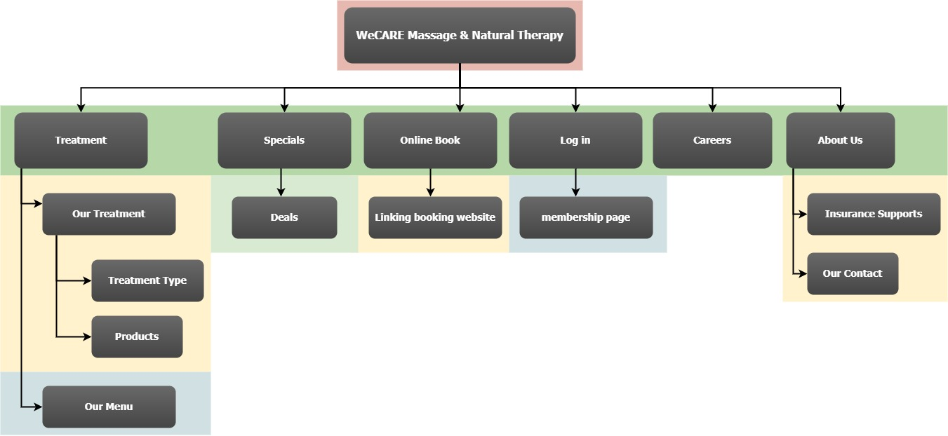

**Can we make a home page design or a design on photoshop just to show her**

**Marking Rubric for Project Documentation:** This assessment rubric provides you with the characteristics of exemplary, competent, marginal and unacceptable work in relation to task criteria.

|  |  |  |  |  |
| --- | --- | --- | --- | --- |
| **Criteria** | **Exemplary (DISTINCTION-level)** | **Competent (CREDIT-level)** | **Marginal (PASS-level)** | **Unacceptable (FAILED-level)** |
| **Assignment is done in a group with 2-4 students.** | **20**  Group demonstrated **exemplary ability** to work collaboratively, e.g. all team members always attended the same workshop | **15** Group demonstrated **competent ability** to work collaboratively, e.g. all team members nearly always attended the same workshop. | **10**  Group demonstrated **marginal ability** to work collaboratively, e.g. all team members sometimes attended the same workshop. | **0**  Group did not demonstrated ability to work collaboratively. |
| **Project description for non-ICT-technical stakeholders and general audience** | **20**  Project is described **very clearly** for a non-technical audience. No presentation and style errors | **15** Project is described clearly for a non-technical audience; or Outside page limits, or Minor presentation and/or style errors. | **10** Project is not described clearly. Outside page limits; or Major presentation and/or style errors. | **0**  Not done, or done unacceptably. |
| **Project Planning and scope** | **20**  All user stories are correct, and correctly estimated. | **15** Most user stories are correct, and correctly estimated. | **10**  More than half of user stories are correct, and correctly estimated. | **0**  Less than half of user stories are correct, and correctly estimated. |
| **Project client signed the scope** | **20**  Intellectual property (IP) in client agreement; Clear evidence of clients priority and ranking of user stories; Signed and agreed scope. | **15** Some evidence of clients priority and ranking of user stories. Signed and agreed scope | **10**  No evidence of clients priority and ranking of user stories.  Signed and agreed scope. | **0**  Not done, or done unacceptably. Project scope is not signed. |
| **Project development and alpha-release ICT infrastructure** | **20**  Description very clearly communicates exemplary ICT solutions. | **15** Description clearly communicates competent ICT solutions. | **10**  Description communicates ICT solutions. | **0**  Not done, or done unacceptably. |

## Reference MIT course and learning outcomes

|  |  |
| --- | --- |
| MIT course & CP5046 subject learning outcomes | * SLO - Subject Learning Outcome * SLO-1 - Communicate technical information clearly through presentations, demonstrations and documentation; * SLO-2 - Choose and apply the appropriate agile methodologies; * SLO-3 - Evaluate and select appropriate tools and technologies to meet project requirements * SLO-4 - Develop a general knowledge of industry standard project management approaches; * SLO-5 - Critically reflect on progress to tailor self learning goals to advance professional development; * MLO - MIT Course Learning Outcome * MLO-K1 - Critically analyse to select appropriate tools and technologies to meet project requirements; * MLO-K2 - Evaluate industry standard contexts for project management approaches; * MLO-S4 - Apply lateral and original thinking to conceptualise and evaluate a range of solutions to relevant problems; * MLO-S5 - Communicate technical information clearly through presentations, demonstrations and documentation; * MLO-A1 - Apply appropriate tools and technologies to meet project managements; * MLO-A3 - Critically reflect on progress to tailor self-learning goals to advance professional development. |